DNA Match Placement Reference Guides
I. Autosomal DNA matches
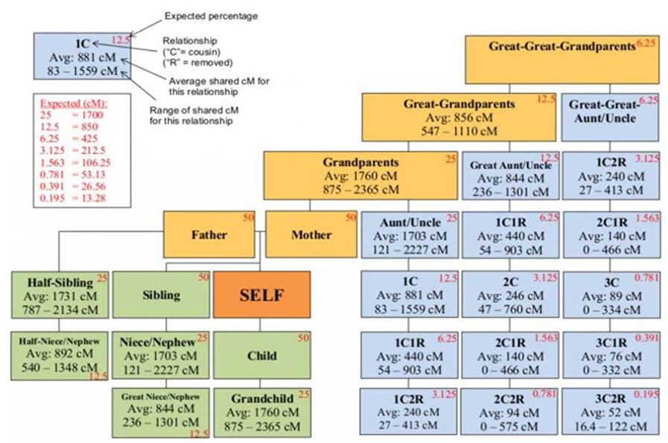
A. Shared cM Project – 2015 Chart https://thegeneticgenealogist.com/2015/05/29/visualizing-data-from-the-shared-cm-project/

This chart and the next chart were published by Blaine T. Bettinger with a CC 4.0 attribution license. No changes were made to his material.
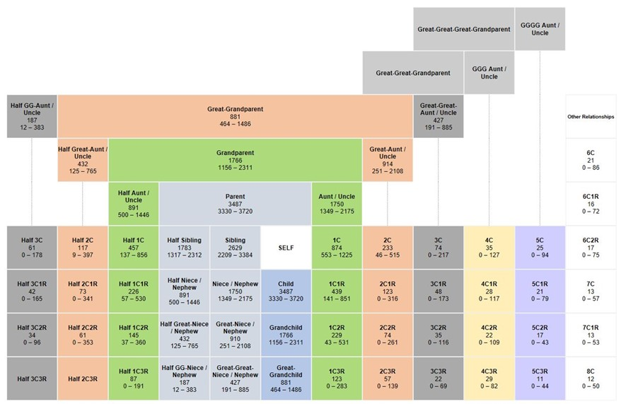
B. Shared cm Project – 2017 Chart https://dnapainter.com/tools/sharedcmv4

C. Ancestry’s cM Possible Relationship Chart
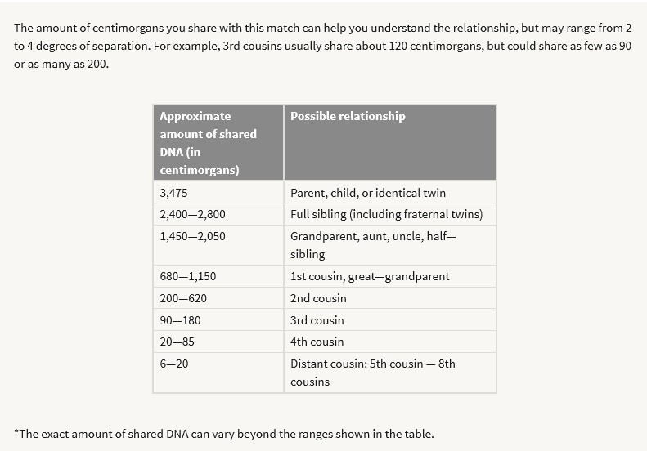

II. X-DNA matches.
A. Male Charts
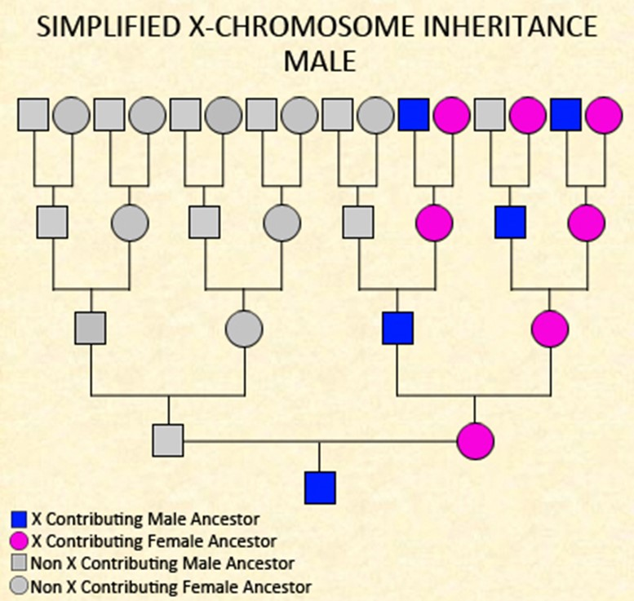
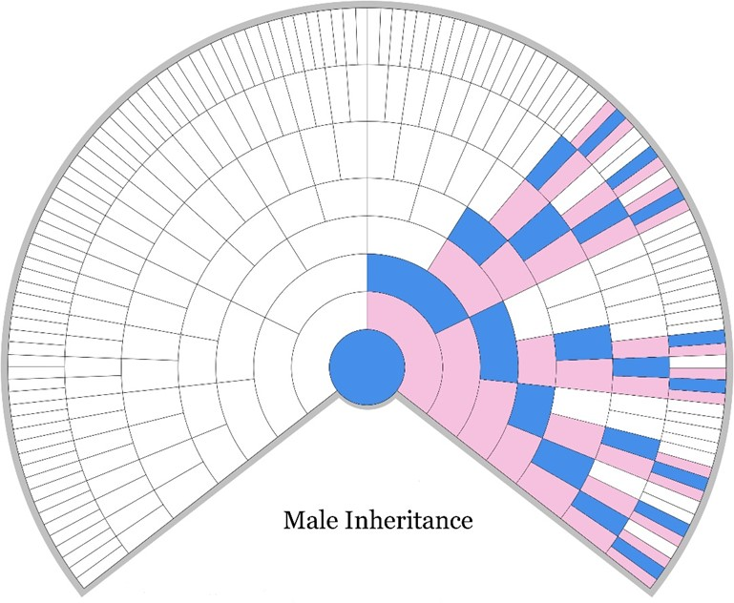

B. Male Rules
1. The male receives an X chromosome from his mother.
2. The male passes down his X-DNA to his daughters.

C. Female Charts
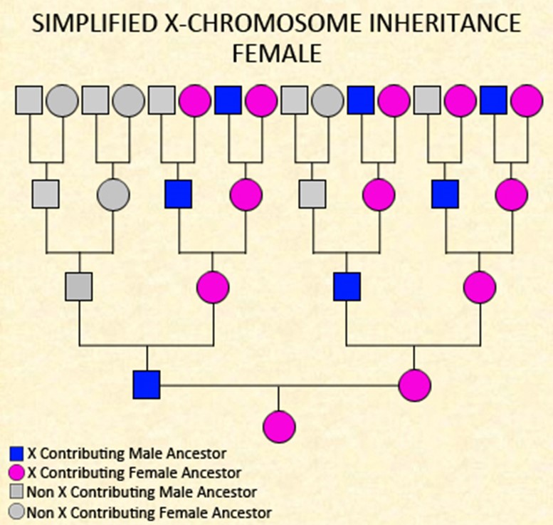
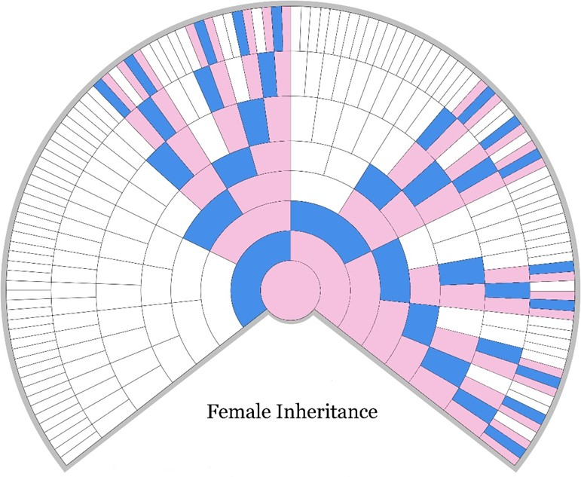

D. Female Rules
1. The female receives and X chromosome from her father and mother.
2. The mother passes down an X chromosome to male and female children.
3. The mother may pass down a recombined X chromosome and the child inherits traits from both maternal grandmothers.

A Guide to Placing X-DNA Matches in Your Genealogical Tree
- General
- You can attribute X segments to particular grandparents by comparing your X-DNA with cousins and other close relatives from each side of your family.
- Focus on larger segments of 20cM or more. Smaller segments may not be reliable.
- Mitochondrial DNA is not the same as X DNA. mtDNA is inherited maternally. Mothers give their mtDNA to all her children. mtDNA is not part of the 23 paired chromosomes. It surrounds the nucleus of each cell.
- The X chromosome does recombine when it can, or at least has the capacity to do so. This means that a female who receives an X from both her father and mother receives a recombined X from her mother, but receives an X that is not recombined from her father. In the mother, the X recombines “in the normal way” meaning that parts of both her mother’s and her father’s X are given to her children, or at least that opportunity exists.
- X DNA can define maternal and paternal lines for females. Cousins may be separated into maternal and paternal lines.
- Adoptees may use X-DNA as a tool to help identify their biological mother, siblings, and/or half siblings.
- People who must share X-DNA include a mother and her children, a father and his daughters, and sisters who have the same father.
- Females
1. A daughter will share a whole X chromosome with her father.
2. Full sisters will share a whole X chromosome, from their father.
3. Half-sisters will share a whole X chromosome if they have the same father.
4. Fathers contribute their whole X DNA to their daughters.
5. If a female has an X DNA match, the shared ancestor must come from the female inheritance pattern.
6. If half-sisters with the same mother share most of their X-DNA, they would have inherited it either from the same maternal grandparent, or the same or very similar recombined X.

7. The X chromosome does recombine when it can, or at least has the capacity to do so. This means that a female receives an X from her father and a recombined X from her mother, with traits from her maternal grandmother and great-grandmother.
8. If half-sisters with the same mother share very little X-DNA with each other, one would have inherited most of her X from her mother's father and the other would have inherited most of her X from her mother's mother, or they each inherited the exact opposite of a recombined X.
- Mothers
1. The X chromosome does recombine when it can, or at least has the capacity to do so. In the mother, the X recombines “in the normal way” meaning that parts of both her mother’s and her father’s X are given to her children, or at least that opportunity exists.
- Males
1. If a male shares X-DNA with a match, then the ancestor in common will be on his mother's ancestral lines, according to the X inheritance patterns in the 'Male' chart.
2. All of a male’s X DNA comes from his mother.
3. If a male has as an X DNA match, the shared ancestor must come from the male X DNA inheritance pattern (maternal ancestral line).
4. If brothers share very little X-DNA with each other, one would have inherited most of his X from his mother's father and the other would have inherited most of his X from his mother's mother, or they inherited the exact opposite of a recombined X.
5. If brothers share most of their X-DNA, they would have inherited it either from the same maternal grandparent, or the same or very similar recombined X from both maternal grandparents.
- Fathers
1. A daughter will share a whole X chromosome with her father.
2. Full sisters will share a whole X chromosome, from their father.
3. Half-sisters will share a whole X chromosome if they have the same father.
4. Fathers contribute their whole X DNA to their daughters.
- Siblings
1. If siblings have tested their autosomal DNA, and a brother has X-matches in common with his sister(s), then the sisters will know that those particular X-matches must have come from their mother, as their brother could only have inherited them from their mother.

